ROD Vol 651 Fol 32 Elizabeth Morry-James O'Toole 10-11-1928

Magistrate’s Office

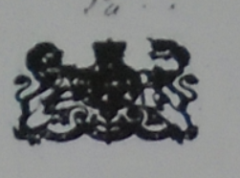 32 Ferryland

Newfoundland }
Southern District }
Ferryland Court }

The Indenture made the tenth day of November
in the year of our Lord one thousand nine hundred
and twenty eight between Elizabeth Morry, Spinster of Calvert
in the Electoral District of Ferryland in the Island of New-
foundland of the one part and James O’Toole of the same
place, fisherman of the other part. Witnesseth that in con-
sideration of the sum of Two ^{Four} hundred and fifty dollars paid by the
said James O’Toole to the said Elizabeth Morry, the receipt whereof is hereby
acknowledge, the said Elizabeth Morry as beneficial owner doth hereby
convey to the said James O’Toole all that piece or parcel of land situate at
Calvert aforesaid bounded on East by Terence O’Toole on the West by Matthew
Whalen on the South by Michael Power, To hold the same unto the
said James O’Toole forever.
In witness whereof the parties to these presents have herewith
their hands & seals, subscribed and set the day & year
first before written }
Signed sealed and delivered } Elizabeth Morry [LS]
by the said Elizabeth Morry }
in presence of }
R. Jardine Freebairn } James O’Toole [LS]
Commissioner } R.J. Freebairn Comm.

Newfoundland
Ferryland, S. D. 33

I, R. Jardine Freebairn, of
Ferryland, aforesaid, retired magistrate,
make oath and say that I was personally present
and did see Elizabeth Morry and James O’Toole
the parties named in the foregoing deed and to me
personally known duly execute the same and
that I am the subscribing witness to such signatures.
Sworn at Ferryland,
aforesaid, this ____
day of August 1934,
before me

Commissioner of affidavits
Supreme Court of Newfoundland

34

Received from
James O’Toole the sum
of four hundred dol
lars $400 this day
Nov 12th 1928
Elizabeth Morry

NEXT PAGE

Caption on the diagram of the property changing hands:
Part of the Estate of the late Matthew Morry ^{Esq, (Merchant)} , Caplin Bay
Scale 4 chains to the Inch 35

All that piece or parcel of land situate N.W. of Caplin Bay River Head Abutted and
Bounded as follows On the North by land occupied by Matthew Whelan. East
by High Water mark. South by Terance Toole [sic] ^{west} Michl. Power, and main
line. Station coord. at the N.W. angle at main line where a large Rock
bears N.76° E. marked thus ^. and running by magnet in 1869 N. 72° E 600 links
more or less &c as per diagram area 4 acres 0 R. and 20 Perches, more or less
Caplin Bay }
May 26th 1869 } Michael Kelly, Dep. Sur.

Registered 28th day of October
A.D. 1963 at 12^{’10} o’clock p m
Vol. 651 Fol. 32-35
J. A. Richards
Registrar of Deeds [$5 Revenue Caribou stamp]

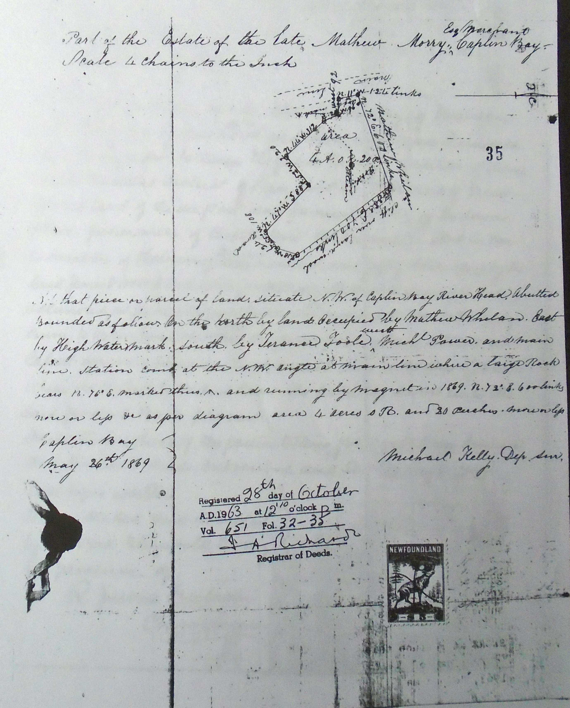

No date included.
No signature
This receipt is in the very shaky handwriting of Elizabeth Morry. The fact that the sum she is acknowledging is $400 and not $450 as the deed suggests makes me wonder if the poor old woman was being taken advantage of and never got the full amount to which she was entitled.

