SDC Vol 2 No 737 Folio 383-386 Grant to Nicholas Brand 20-01-1848
Editorial Note: Much of the text in these grants is boiler plate with the particulars of the piece of land being handwritten in the appropriate places. To distinguish between the boiler plate and the specific details of the transaction the latter are shown in italics.
J. Gaspard Le Marchant
{L.S.}
No. 737
Newfoundland


WILLIAM the Fourth ^^{Victoria} by the
Grace of GOD of the United Kingdom of Great
Fees | Stg.
Great Seal
Secretary
Surveyor
Dep^{y} Surveyor

Britain and Ireland King [sic] Defender of the Faith

To all to whom these presents shall come Greeting

KNOW ye that WE of our special grace
certain knowledge and mere motion have given and granted and by these Presents
do for Us our heirs and successors Give and Grant unto Nicholas Brand
of Topsham in the County of Devonshire England

His heirs and assigns all that piece and parcel of Land situate and being on the
North East Side of Aquaforte Harbor abutted and bounded as follows
that is to say by a line commencing at a large rock called the Kettle
rock situate bear the Pool and Marked I.B. and N.B. thence bounded
by land belonging to the estate of the late William Carter and running
by the magnet (in 1848) north Sixty Seven degrees thirty minutes East
two chains and twenty four links more or less to another rock also marked I.B. thence north
forty eight degrees thirty minutes east five chains and twenty eight links more or less to a third large
rock near a Public Road, thence South Sixty five degrees thirty minutes East four chains
more or less to land belonging to the estate of the late Robert Carter, thence bounded by
the land last mentioned, and extending by an irregular line measuring in the
whole ten chains and ninety links more or less to the Shore, thence following the
direction of the shore Westerly nineteen chains and twenty links more or less, to
the Western extremity of the Point of Beach, thence following the direction of the
Said point of Beach easterly and North Westerly bound as Sheet of Water known
as the Pool ten chains more or less to the said rock marked as aforesaid
I.B. & N.B. and place of Commencement Saving and reserving notwith-
standing to the use of the Public a road to be preserved not less than twenty
feet Wide running through the Southern part of the land here described
Such road being a main road and leaving from Aquaforte to Ferryland
and also Saving and Reserving a foot path leading through the Said here
described land to land belonging to the estate of the late William
Carter and being of the dimension specified in the diagram
delineated on the other side hereof.

in our Island of Newfoundland bounded as the same is delineated and described
in

in the diagram hereunto annexed and containing Ten Acres Three Roods and
Twenty Perches more or less.

with the appurtenances except and reserved nevertheless out of this present
Grant to Us our heirs and successors all Gold and Silver and all Coals and other
Mines and Minerals in or under the said piece or parcel of Land.
To Have and to Hold (except as before excepted) unto the said
Nicholas Brand

His heirs and assigns for ever He the said Nicholas Brand paying onto
us as the price and consideration of the said land the Sum of Eleven
Shillings Sterling money at the time of the ensealing and delivery hereof.
heirs and assigns yielding and paying therefore yearly and every year
for ever unto Us our heirs and successors at the Office of the Secretary of our Go-
Examined Jany. 17. 1849
E. M. Archibald
H. M. Atty. Genr.

vernor of our said Island for the time being in the Town of St. John’s in our
said Island of Newfoundland or to such other person as shall be appointed to
receive the same the yearly Rent or Sum of
Sterling Money of our said United
Kingdom for each and every Acre of the said Land hereby granted to
commence on the 24th day of June which shall be next after the expiration of
Two Years from the day of the date hereof and to be paid yearly and every year
on the 24th day of June for ever. And in default of the said payment or if it shall
happen that the aforesaid yearly Rent shall be at any time behind and unpaid in
the whole or in part by the space of Thirty Days next after any day whereon the
same ought to be paid as aforesaid then and from thenceforth this Grant shall
immediately cease and determine and be void and of non effect and the said Land
and Appurtenances shall revert to and revest in Us our heirs and successors.
Provided always that and this Grant is upon condition that
part or portion of the Land hereby granted shall be properly cleared cleansed
and cultivated within the period of Three Years next ensuing after the day on
which Rent shall first become due and payable under the provisions of this Grant.
Provided also and this present Grant is upon condition that the same Grant
be registered in the Office of Registry of our Southern District Court of
Newfoundland within Three months next after the day of the date hereof
or otherwise that the same shall be void and of non effect. Provided also
and this present Grant is upon condition that the said Lands shall be holden
upon under and subject to such regulations as may at any time hereafter be made
by Law for the improvement and cultivation of Lands within our said island of
Newfoundland and subject to all regulations as may at any time hereafter be
made by Law for making Roads Sewers Drains Canals Bridges or other Public
Works or Improvements within our said Island of Newfoundland or any part
thereof and for subjecting any Lands therein situate or the owners or occupiers of
such Lands to rates and assessments or other duties or services for the purposes
aforesaid or for any of them. And that the said Nicholas Brand
His heirs and assigns shall at all times
peaceably quit and deliver up possession to Us our heirs and successors of all such
parts of the Lands aforesaid as may be required for the purposes aforesaid or any
of
of them upon receiving such compensation (if any) as by any Law hereafter to
be made in that respect may be provided.

Given under the Great Seal of our Island of Newfoundland
at St. John’s this twentieth day of Januaary
in the Year of our Lord One Thousand Eight Hundred and
Forty Thirty Eight and in the twelfth Year of our Reign.

Witness our trusty and well beloved Sir John Gaspard Le Marchant
Knight and Knight Commander of the orders of St. Ferdinand and of Charles the third of Spain
our Governor and Commander in Chief in and over
our said Island and its Dependencies &c.

By His Excellency’s Command
Ja^{s.} Crowdy
Received the day and year above written from the within named
Grantee the sum of Eleven Shillings amount of the consideration
Money of the land herein granted.
Ja^{s.} Crowdy
£0.11.0 Secretary

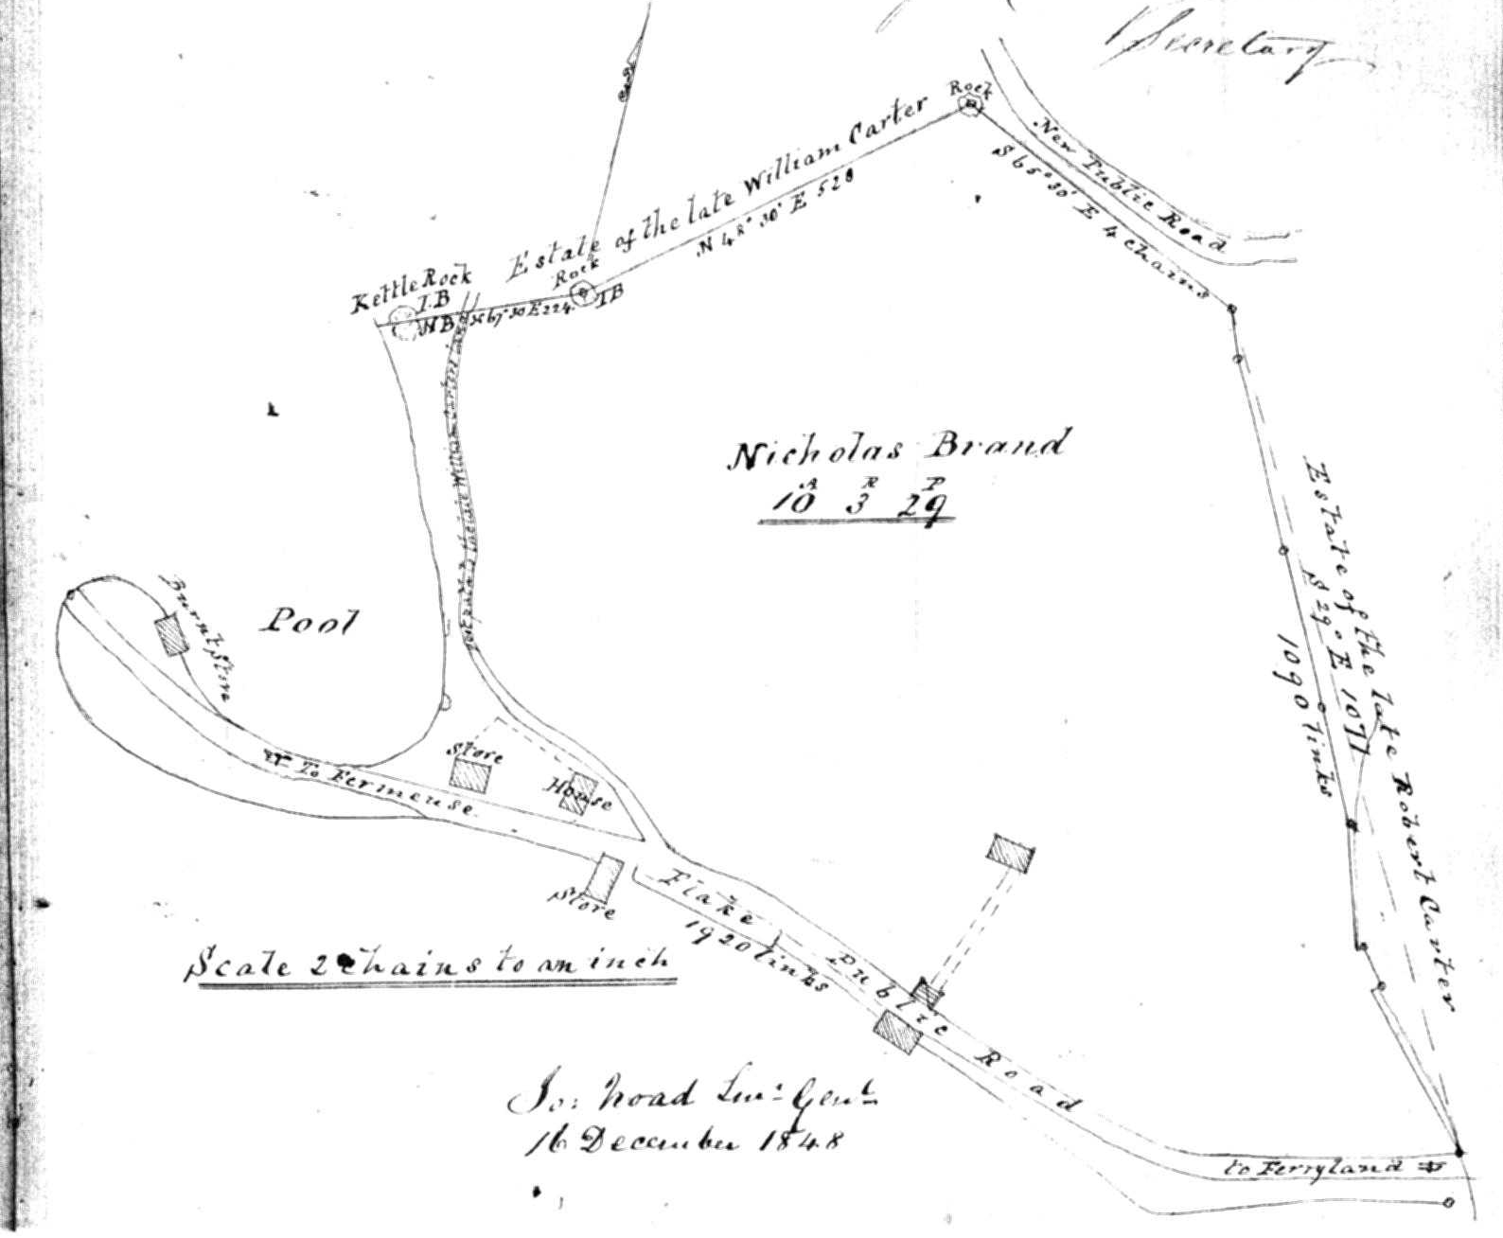

I do hereby Certify that the foregoing Grant of Land
No 737 to Nicholas Brand of Topsham in the County of
Devonshire England was duly registered this eighth day
of December AD one thousand eight hundred & Forty Eight.

George Simms
Registrar

